

Remove excess lubrication oil
- Connect gauge manifold to the discharge and suction ports.
- Operate the unit for about 5 minutes and stop the unit.
- Operate the S-PTI (Short PTI) and stop the unit at step of "P10".
  - Switch OFF and ON the unit
  - Go to PTI sellection mode by pressing key immediately for 3 seconds
  - Sellect S-PTI using or key and press key, and S-PTI operation starts.
  - Stop the unit with ON/OFF switch when P10 is displayed on the LED
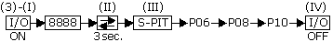
*P06 (HPS check)
When high pressure rises, the circuration amount of refrigerant increaces to return the oil to the compresor.
*P08 (Pump down check)
Evaporates the refrigerant contained in the compressor oil.
- Adjust low pressure to 0 kPa or more by bypassing gas from high pressure side to low press. side of gauge manifold.
- Connect the recovery machine to the gauge manifold and recover the small amount of refrigerant, which is in the compressor.
- When the refrigerant is out of the compressor, add a little nitrogen (0,1 bar) in the compressor, to have a small overpressure which press the excess of oil out of the compressor.
- Loosen the oil drain plug and remove the excess oil, by collecting the oil in a special can.
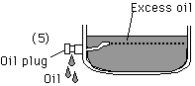
7
- Close the oil plug, when no oil comes out anymore and nitrogengas starts coming out.
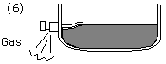
8
- Release the nitrogen and vaccuum the compressor
- Take off "Remove excess oil" lavel sticked on compressor body.
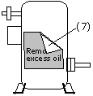
10

